**Adding a New Product in the Database**

**Screenshots:**

**Index page:**

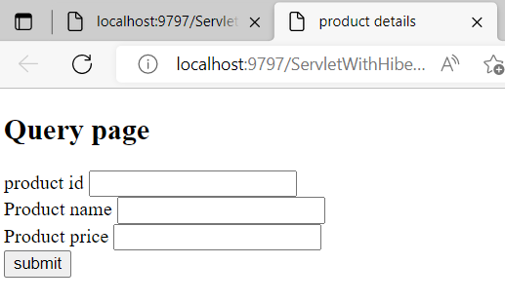

**After entering the details**

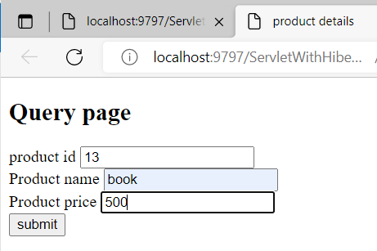

**After submission, if the id is not present the record is inserted**

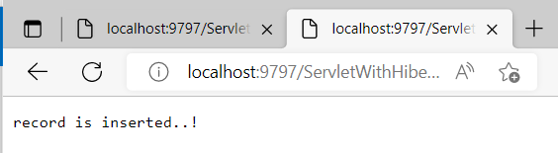

**Select query in database**

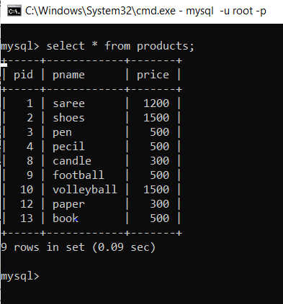

**After submission , if the pid is already present**

